Floyd-Floyd County PSA

Water/Wastewater Board Meeting

February 8, 2024

Chairman Mike Maslaney called the Thursday February 8, 2024, meeting of the Floyd-Floyd County PSA to order at 5:30pm. In attendance was Vice Chairman Will Griffin, Director Bruce Turner, Director Jerry Boothe, and Director Rick Parrish. Others in attendance were Clerk Teresa Conner, Superintendent Patrick Nicola, Attorney Janet Murrell, and Engineer Matt Gross via zoom.

Chairman Mike Maslaney asked everyone to look over the January minutes for approval. Director Bruce Turner made a motion, seconded by Director Rick Parrish, to approve the January minutes. Roll call of members replying yes, with Director Jerry Boothe abstaining. Motion passed.

Chairman Mike Maslaney moved to the Treasurers report. Clerk Teresa Conner reviewed the Accounts payables for January 2024. No questions were asked, Chairman Mike Maslaney entertained a motion to approve. Director Jerry Boothe made a motion, seconded by Director Bruce Turner, to approve the January 2024 account payables. Roll call of members replying yes, motion passed.

Chairman Mike Maslaney discussed the financials. We are doing good, just $17k under in income and expenses are high but we had the RBC bearings, Audit and Insurance payment which was 54k. Chairman Mike Maslaney said if no questions entertain a motion to approve. Director Rick Parrish made a motion, seconded by Director Bruce Turner, to approve January Financials. Roll call of members replying yes, motion passed.

Chairman Mike Maslaney discussed the Capital Expenditures that is in the board packet. He had planned to go to the BOS to present but they are busy, so Director Jerry Boothe has agreed to carry the flag in this at next week’s BOS meeting. We need to see about moving the ARPA funds remaining from the County over to sewer projects (Slaughters, Nursing Home, RBC bearings).

Chairman Mike Maslaney asked for a motion to approve the lowest bidder Bowman & Griffith for the projects with VDH (221 Waterline replacement, Sweeney St, Well 6 filter, System Disinfection). Director Jerry Boothe made a motion, seconded by Director Bruce Turner, to accept the lowest bidder Bowman & Griffith for the VDH projects. Roll call of members replying yes, motion passed.

Chairman Mike Maslaney said we received the award letter from VDH for the LSL Inventory project. This is a project required by VDH and is all principal forgiveness. Engineer Matt Gross, Hurt & Profitt along with Superintendent Patrick Nicola will be working on this project.

Chairman Mike Maslaney asked Attorney Janet Murrell if she had anything to report on. Attorney Janet Murrell did not have anything to report.

Superintendent Report:

# Water Breaks Ian 24th:

Had a 4-inch main line break in front of the Moose Lodge, so we called Justin and set up a time to meet us there. While waiting for that ticket to clear we received another call from The Station, which was a 2-inch water leak at the meter on our side. We called in the ticket then headed down to meet Justin. As we completed the repair of the 4-inch, another call came in about a problem on Oxford St. Once arriving at the site, we noticed water running down the road. We called in the ticket and during that time we began to set up on Oxford and shut the road down, Teresa sent out an alert text, notified the Sheriff’s Office and began to call customers that would be affected by the water cutoff. Unfortunately, we had no choice but to cut open the road. We found the leak was due to a saddle that had completely rusted off the main line. The repair was made at which point we moved over to The Station and repaired the 2-inch leak.

# McCrays Impeller install:

Jodie (Tencarva Tech) completed the installation of the impellers and cutters on both the pumps at the Main Pump Station. Since the installation we have seen the run times drop significantly due to the increased volume of the pumps.

# Well 6:

About a month ago the motor drive at Well 6 had cut off a few times due to a voltage imbalance or phase loss. We had the issue looked at and it was determined the buss bar in the breaker panel needed to be replaced due to corrosion and burnt leads. The panel was ordered but had a 2-week lead time. Of course, as the cold weather came in the drive got to the point it wouldn't stay running. Water demand began to increase nearly 100,000 gallons so the wells needed to be operated in hand for extended periods of time. Thankfully the panel did arrive and Tesla Electrical was able to get the parts replaced and the Well back online.

# Updates/Notes:

* + The Plat for Slaughters has been filed with the County and Clerks Office. We also received the approval letter and signed CTC for Slaughters Pump Station.
  + LSL Inventory Grant Virtual Initial Meeting was on Jan 31
  + Went by the nursing home and spoke with Joe over maintenance about the rag/wipe problem.
  + Attached are Water Loss and Sewer flow I&! Percentage's

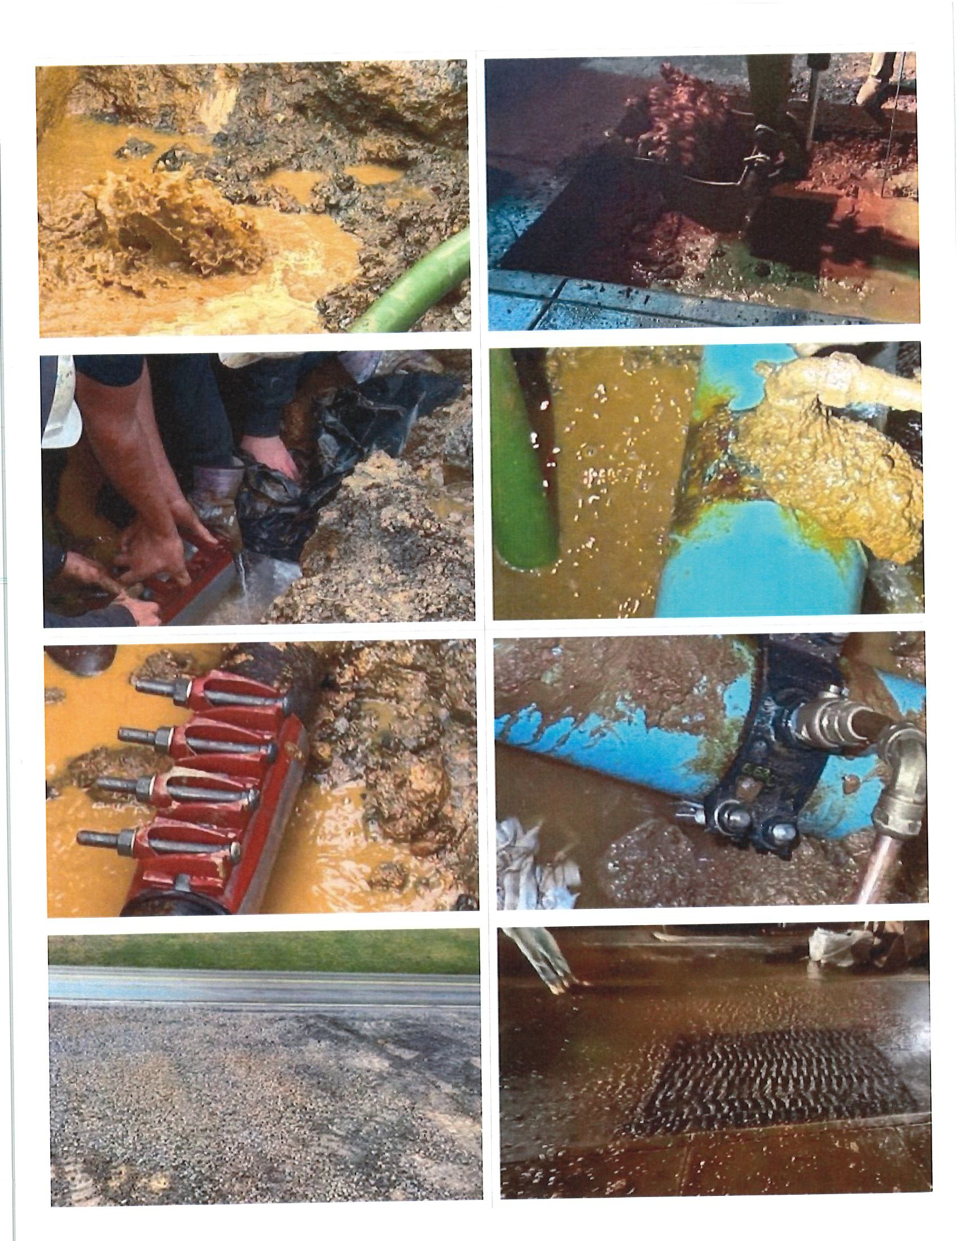

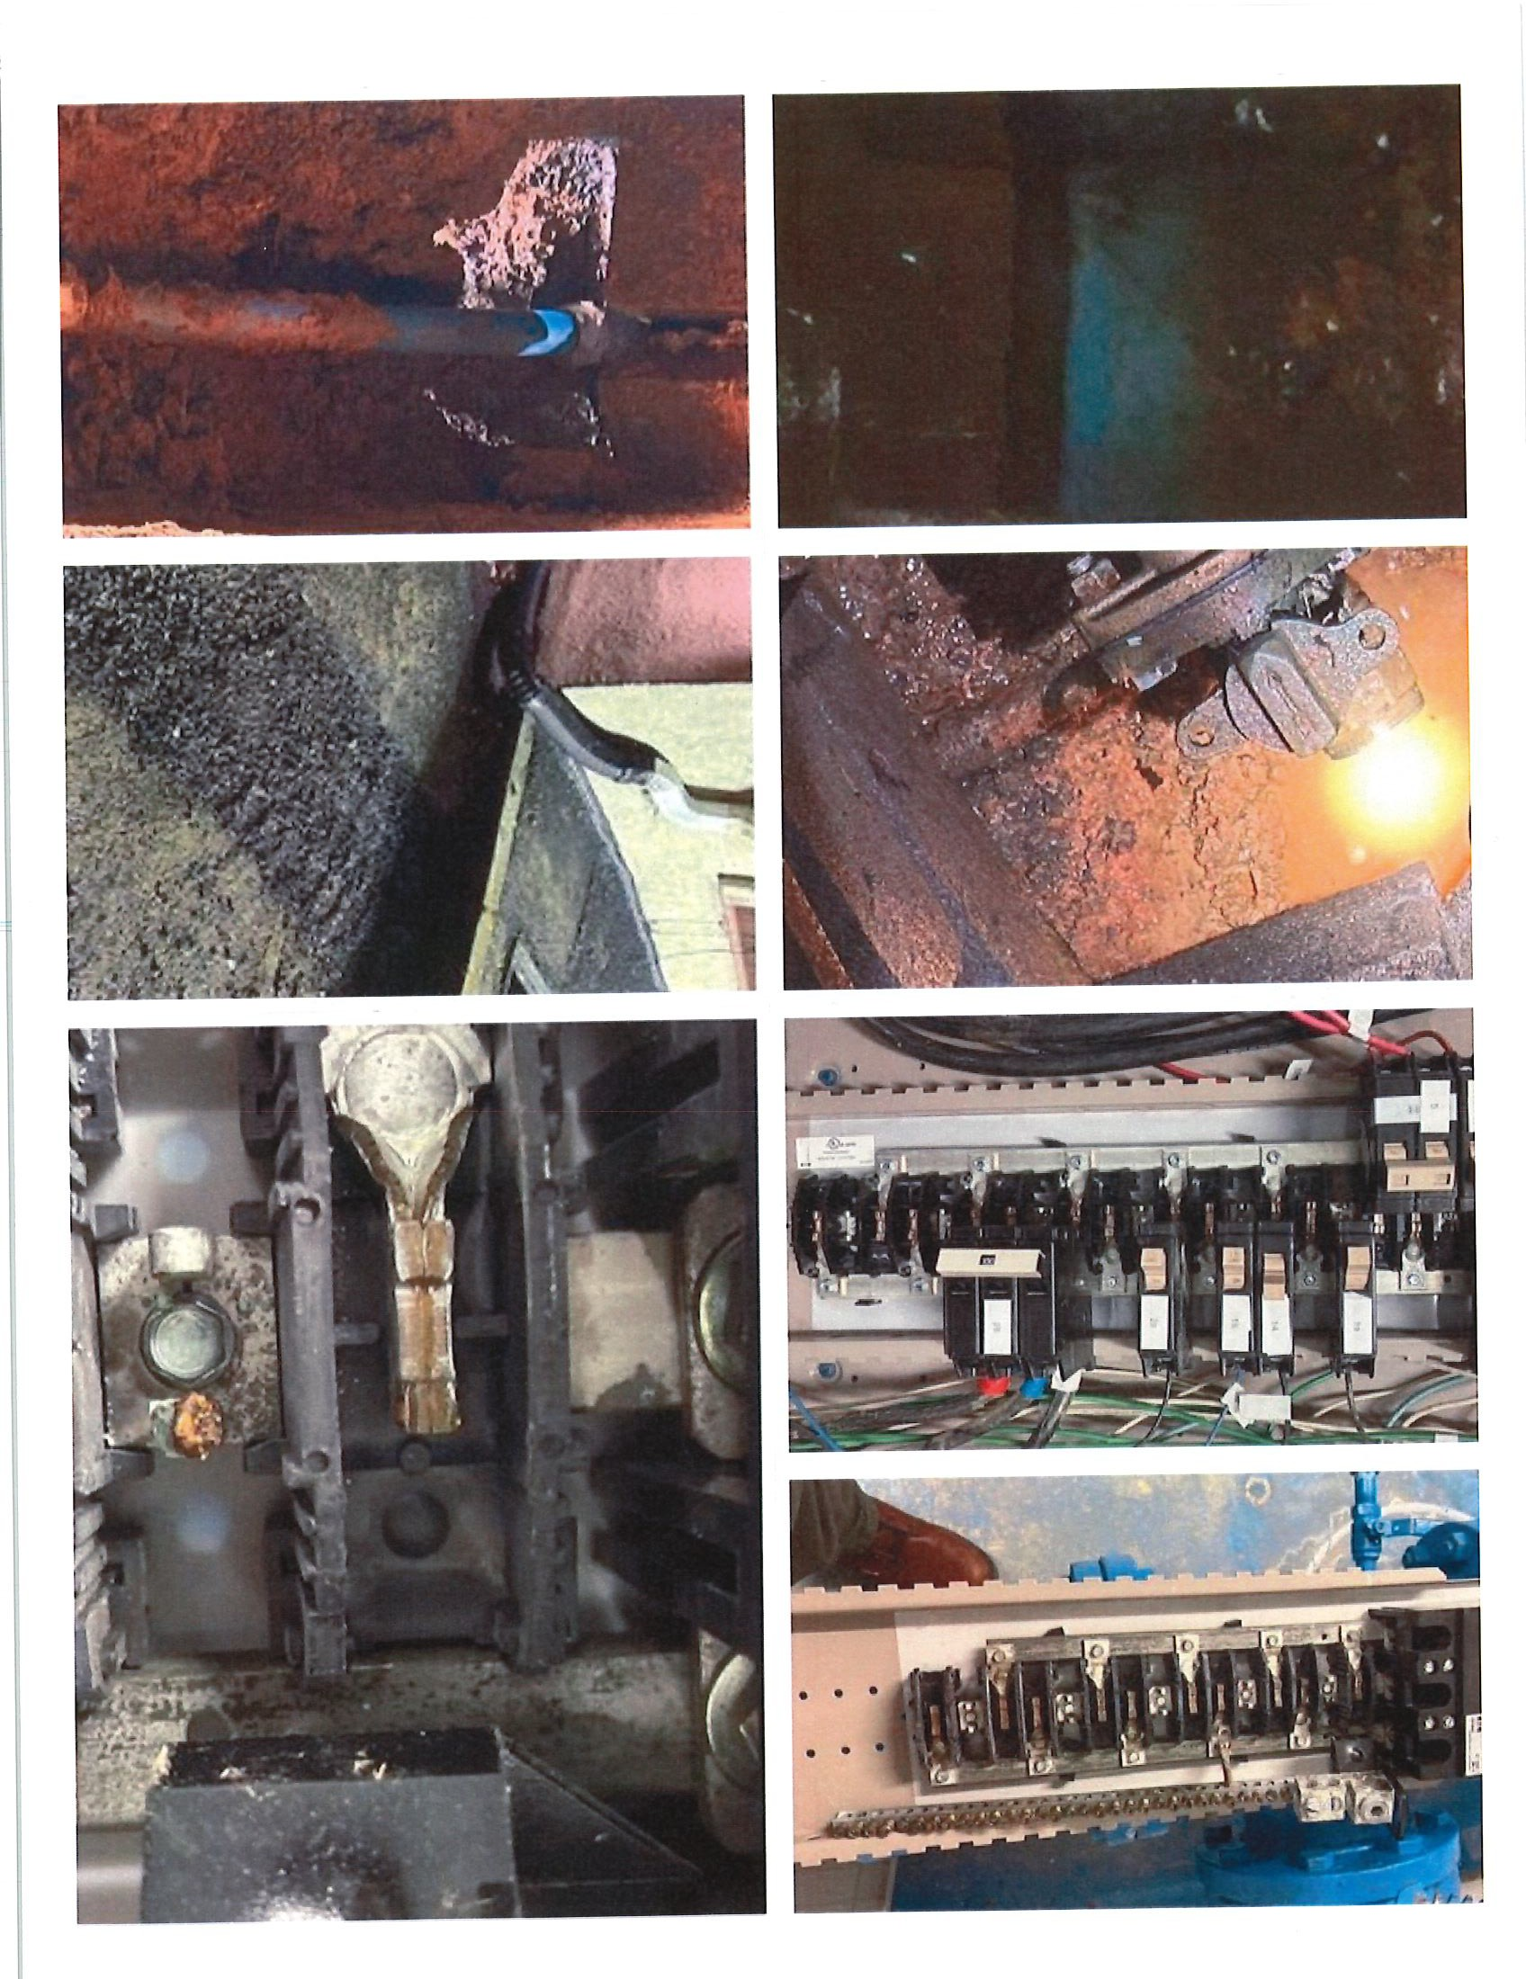

1. **VDH Funding Water System Improvement Projects**

Various documents have been submitted to VDH for concurrence on the award for all three projects. VDH has indicated that they do not have any issues with the selection of the contractor. There is little discussion right now regarding the proposed equipment for the Well 6 greensand filter, but that should not affect award. As of 2/7/24, the equipment was tentatively approved by the Health Department pending formal submittals.

1. **Nursing Home Pump Station Replacement**

The complete package will be submitted to the PSA for final review after AEP confirmed 460 V, 3 Phase power was available.

1. **LSL Inventory**

Work will commence on this project once the grant offer has been finalized. We attended the VDH conference on funding on January 31st and have since provided VDH with the requested methodology information.

1. **Additional Well Drilling**

The VDH planning grant has been submitted.

1. **Slaughters Pump Station**

The permit has been renewed for this project.

Chairman Mike Maslaney asked if there was any other business to discuss. No other business was to be discussed and entertained a motion to adjourn. Director Jerry Boothe made a motion, seconded by Director Bruce Turner to adjourn. Roll call members replied yes. Motion passed.